RetentionIQ — Final Project Deck
FinPro | Barcelona Technology School | 2026 Team: Franca · Marten · Eric · Kimberly · Davidson · Giulia · Juan Pablo · Tanzeel-ur

1. Executive Summary
Most Shopify brands do not know which customers are about to stop buying from them. They send the same emails to everyone, offer discounts to people who would have come back anyway, and miss the ones who are quietly leaving.
RetentionIQ was built to change that. It is a platform that tells a brand, for every customer, how likely they are to churn, why, and what to do about it. We built and tested it on real data from Miracle Sheets, a DTC bedding brand with over 750,000 customers and more than $156 million in historical revenue.
The results: a churn model with an AUROC of 0.70 across 66 features, a working CLV forecast for every customer, and a live dashboard connected to a prediction API that any marketing manager can use without opening a spreadsheet.

2. Introduction
Who we are
FinPro is an eight-person team from the Master in Big Data and AI Solutions at Barcelona Technology School. Between us we cover data engineering, machine learning, backend development, frontend design, and product strategy. We spent the last few months building RetentionIQ as our final project, working with real ecommerce data from the start rather than synthetic datasets.
What we do
RetentionIQ connects to a Shopify store, processes its full order history, and gives two outputs for every customer: a churn risk score with an explanation of why that customer might leave and a lifetime value forecast that shows how much they are worth trying to keep.
Why we do it
The numbers from our own pilot data were clear. 88% of Miracle Sheets customers bought once and never came back. Getting a new customer costs five times more than keeping an existing one, and a 5% improvement in retention can lift profits by up to 25%. Even so, most brands still rely on gut instinct or generic email campaigns to manage retention. We thought that was a problem worth solving.
How we do it
We pull order and customer data through Daasity, clean and organise it into a customer-level feature table, and run two models: XGBoost for churn, with SHAP values to explain each score, and BG/NBD plus Gamma-Gamma for lifetime value. The predictions go through a FastAPI backend and appear on a dashboard that shows exactly who is at risk, why, and what their predicted value is.
Mission
To give every DTC brand access to the kind of customer intelligence that used to require a full data science team.
Vision
To be a revolutionary company that impacts customer retention through AI solutions.

3. Value Proposition
What we stand for
Three principles shaped every decision we made when building RetentionIQ:
- Explain everything. A churn score without a reason is just a number. Every prediction comes with the specific factors that drove it, so the person reading it knows what to do next.
- Built for ecommerce, not borrowed from SaaS. Most churn tools were designed for subscription businesses. We calculated our churn window from the actual purchase behaviour of real DTC customers, not from a 90-day convention that makes no sense for a bedding brand.
- Make it actionable. The prediction is not the point. What happens after it is. Every output in RetentionIQ is designed to lead to a specific next step.
The story
A marketing manager opens RetentionIQ on a Monday morning. She sees a customer with a 92% churn probability. The dashboard tells her the main driver is 287 days without a purchase, but also that this customer has a high average order value, which is a good sign. The CLV tab shows this customer is predicted to be worth $340 over the next 12 months.
She now knows who to contact, why they are at risk, and how much it makes sense to spend to win them back. That is the gap we close.
North Star Metric
Repeat Purchase Rate Lift: the relative increase in a brand's repeat purchase rate after 90 days with RetentionIQ. A brand going from 3% to 5% achieves a +67% lift. That is what we optimise everything around.
How we compare
 | RetentionIQ | Shopify Analytics | Klaviyo | Lifetimely | Retention.com
Churn prediction | Yes | No | No | No | No
CLV forecast | Yes | Partial | Partial | Yes | No
Explanations (SHAP) | Yes | No | No | No | No
Empirical churn window | Yes | No | No | No | No
Action recommendations | Yes | No | Partial | No | No
Starting price/month | Free | Free | $45 | $199 | $5,000+

4. Big Data Solution and Product Development

4.1 Data sources
Our data comes from Miracle Sheets, accessed through Daasity, the data warehouse layer that sits on top of Shopify's Admin API. We worked with two files: an order-level export with 976,659 orders from January 2024 to March 2026, and a customer-level table with 751,956 unique customers.
Before building any model, we cleaned the data carefully. We removed rows with missing customer IDs, order IDs, or dates. We kept only paid and partially refunded orders and removed anything with a non-positive charge. All amounts are in USD. Customer emails are hashed with SHA-256 before use in any output, so no personally identifiable data enters the modelling pipeline.
One thing worth noting: we found a difference between the raw order file and the canonical customer table in how they count repeat buyers. We used the canonical table as the source of truth and documented the discrepancy rather than ignoring it.

4.2 Analysis and visualisation
TO BE FINISH

4.3 Machine learning models
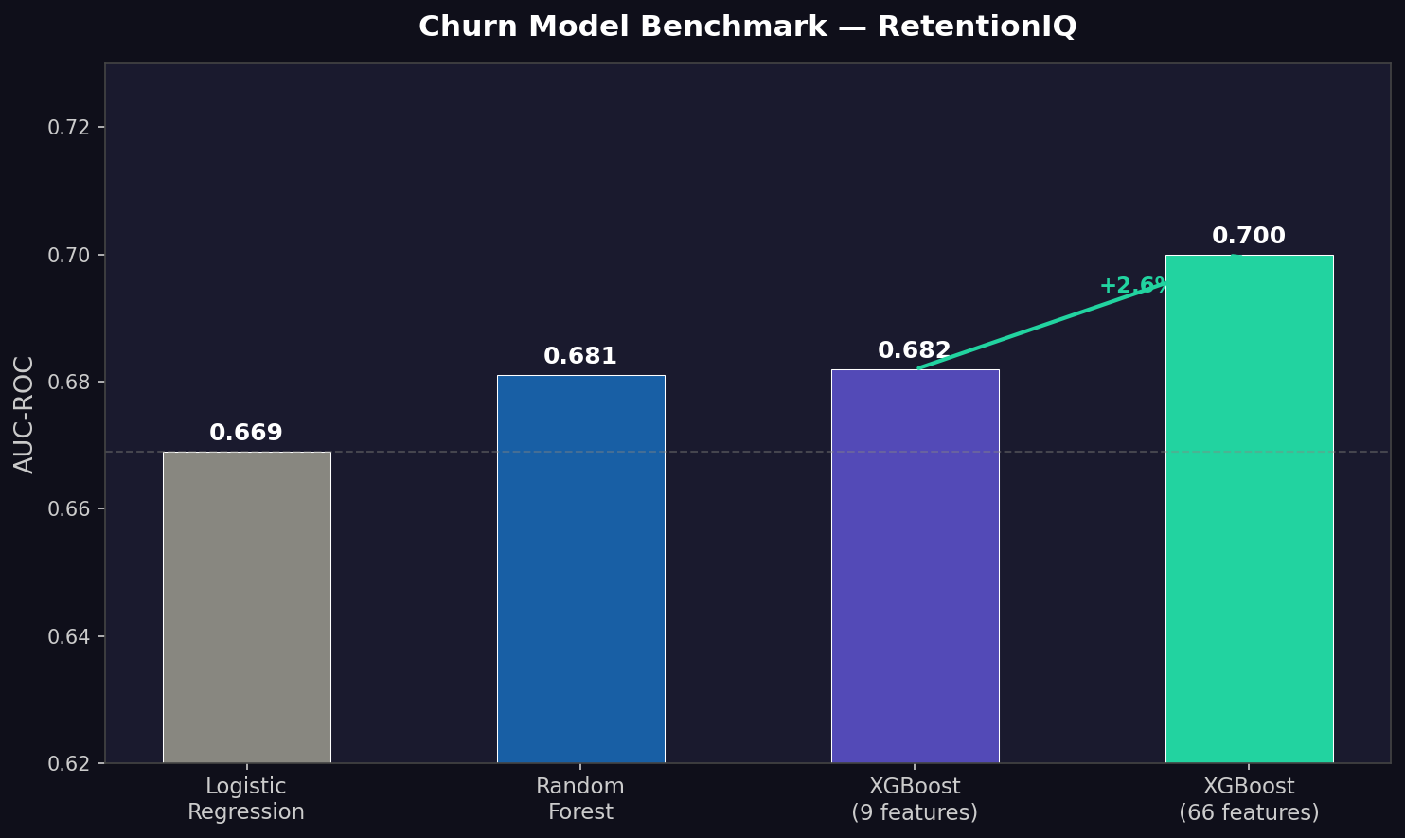
Churn prediction
We tested three models: logistic regression, random forest, and XGBoost. XGBoost came out ahead and became our production model.
The churn label was not a guess. We calculated the 90th percentile of inter-purchase time from the actual data and got 299 days. A customer who has not bought in 299 days is labelled churned. Using a standard 90-day window would have incorrectly labelled 38% of loyal customers as churned.
On top of XGBoost we added SHAP, which calculates for each customer which features pushed the score up and which pulled it down. This is what turns a score into something a team can act on.
Customer Lifetime Value
For CLV we used the BG/NBD model to estimate how many times each customer will buy in the future, combined with the Gamma-Gamma model to estimate how much those purchases will be worth. These models have been used and validated in academic research for over two decades. We chose them because they fit the problem, not because they sound technical.

4.4 Results
In the first version of the model, we used 9 RFM-based features: total orders, total revenue, average order value, recency, frequency, monetary value, refund rate, and tenure. XGBoost reached an AUROC of 0.682, ahead of random forest (0.681) and logistic regression (0.669). Average precision was around 0.97 for all three models, which reflects the balanced class distribution (48.9% churned vs 51.1% active).
In a second iteration, we expanded to 66 features by adding product-level signals aggregated to the customer level: the most frequently purchased product category, colour family, and price bucket per customer, as well as average number of items per order. This pushed the AUROC to 0.70, showing that what customers buy matters as much as when they buy.
For CLV, the BG/NBD and Gamma-Gamma models were fitted on the full customer base and produced stable, non-negative results, allowing predicted CLV to be generated for any customer and time horizon through the API.

4.5 Architecture
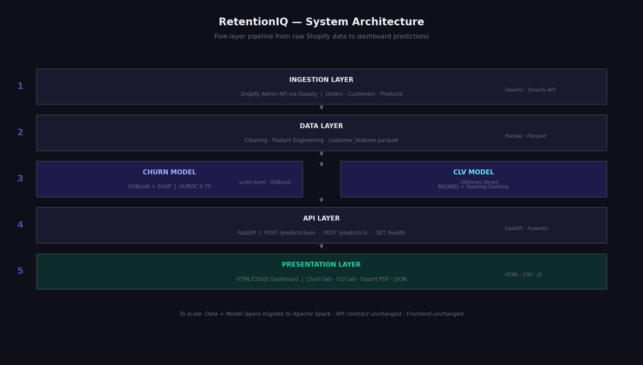
The system has five layers:
- Ingestion: Daasity pulls data from Shopify's Admin API
- Data: cleaning and feature engineering produces a customer-level Parquet file
- Models: XGBoost for churn, BG/NBD plus Gamma-Gamma for CLV
- API: FastAPI serves /predict/churn and /predict/clv
- Frontend: HTML dashboard consumes the API
The most important architectural decision was keeping the frontend separate from the models. The dashboard only talks to the API. That means we can retrain the models, change the features, or swap algorithms without touching the dashboard. It also meant the frontend and the model work could happen in parallel, which is exactly what we did.
To scale to production, the data and model layers would move to Apache Spark for distributed processing, while the API and the frontend stay unchanged.

5. Business Plan
Pricing
We use a monthly SaaS model with five tiers:
Plan | Price | What you get
Starter | Free | Dashboard preview
Essentials | $275/month | Full churn and CLV scores
Growth | $700/month | Explanations and action recommendations
Business | $1,600/month | A/B testing and channel measurement
Enterprise | Custom | API, multi-store, customer success manager
14-day free trial. No hardware. No installation. No data team required.
Who we sell to
US-based DTC brands on Shopify, between $2M and $50M in annual revenue. The US DTC market is worth over $220B in 2026. There are more than 2 million active Shopify stores in the US. Around 72% of DTC customers never make a second purchase. That is our market.
How we grow
- Acquisition: brands find us and sign up for the trial
- Activation: they connect their Shopify store and explore the dashboard
- Retention: they keep coming back during the trial period
- Revenue: they convert to a paid plan
- Referral: they recommend us to other brands
Every stage feeds the North Star: Repeat Purchase Rate Lift.

6. Product Roadmap
Now Shopify integration live. Churn prediction, CLV forecasting, REST API, and dashboard working.
2026 WooCommerce integration (Q3). Action recommendation engine. Klaviyo and Mailchimp direct integrations. First 5 paying customers.
2027 to 2028 BigCommerce and Magento integrations. A/B testing module. Multi-store support. Mobile app.
2029 and beyond Standard retention intelligence layer for Shopify brands globally. Full customer journey modelling. Platform API for agencies and integrators.

7. Conclusions and Future Work
What we built
We started this project with a clear hypothesis: that a small team, working with real ecommerce data and the right tools, could build a working retention product from scratch. We think we showed that is possible.
Starting from raw Shopify exports, we put together a full pipeline from data ingestion to a working dashboard, with two predictive models, a REST API, and an explainability layer. The churn model performs well for this type of problem, the CLV model is based on decades of validated academic work, and the dashboard makes both accessible to people without a data background.
What we learned
The churn window decision had more impact than almost any modelling choice we made. Taking the time to understand the actual purchase behaviour of Miracle Sheets customers, instead of applying a standard threshold, was one of the most useful things we did.
Adding product-level features improved the model in a meaningful way. The jump from 0.682 to 0.70 AUROC came from adding 57 new product-level features on top of the original 9, not from tuning the algorithm.
Keeping the frontend separate from the models from the beginning was the right call. It let Eric and Davidson build and test the dashboard while the modelling work was still ongoing, without either side blocking the other.
On the business side, framing the product around three questions (will they leave, why, what should you do) made it much easier to explain to non-technical people and shaped the design of the dashboard in a way that a list of features never would have.
The three iterations
Iteration 1: baseline pipeline, 9 features, logistic regression benchmark, FastAPI stubs. The goal was to agree on the data contract and let each part of the team work in parallel.
Iteration 2: 66 features including product-level attributes. XGBoost selected as the final model. CLV model fitted. AUROC improved from 0.68 to 0.70.
Iteration 3: SHAP integrated into the API, dashboard connected to live endpoints, export and history features added. Full end-to-end system tested on real customer IDs.
What comes next
Connecting to real-time Shopify webhooks so scores update daily without manual exports. A recommendation layer that matches churn drivers to specific campaign types. Validation on a held-out time window. CLV segmentation shown directly in the dashboard.

8. References
- Harvard Business Review, Reichheld and Schefter: The Economics of E-Loyalty. Source for the 5x acquisition cost figure.
- Bain and Company, Prescription for Cutting Costs. Source for the 25% profit lift from 5% retention improvement.
- Metrilo / Ringly DTC E-Commerce Benchmarks, 2026. Source for the $220B market size and 72% one-time buyer rate.
- Fader, P., Hardie, B., Lee, K. (2005). Counting Your Customers the Easy Way. Marketing Science. BG/NBD model foundation.
- Fader, P., Hardie, B. (2013). The Gamma-Gamma Model of Monetary Value. CLV monetary component.
- Chen, T., Guestrin, C. (2016). XGBoost: A Scalable Tree Boosting System. ACM KDD. Churn model foundation.
- Lundberg, S., Lee, S-I. (2017). A Unified Approach to Interpreting Model Predictions. NeurIPS. SHAP explainability layer.

FinPro | RetentionIQ | Barcelona Technology School | 2026 Franca · Marten · Eric · Kimberly · Davidson · Giulia · Juan Pablo · Tanzeel-ur

